Docker Reference Notes

1. Containerization Concepts

What is Virtualization?
Virtualization is the process of creating virtual versions of physical computing resources such as:
- Servers
- Operating Systems
- Storage devices
- Networks

A special software called a Hypervisor allows multiple virtual machines (VMs) to run on a single physical machine.

Why Do We Use Virtualization?
Virtualization helps organizations:
- Utilize hardware efficiently
- Run multiple OS environments on one machine
- Reduce infrastructure cost
- Improve scalability
- Simplify testing and deployment
Example
One physical server can host:
- Windows VM
- Linux VM
- Ubuntu VM
Each VM works independently.

Virtualization vs Containers
Feature | Virtual Machines | Containers
OS Included | Yes | No
Size | Large (GBs) | Small (MBs)
Startup Time | Slow | Fast
Resource Usage | High | Low
Isolation | Strong | Moderate
Portability | Moderate | Excellent

Virtual Machine Architecture
Hardware
↓
Hypervisor
↓
VM1 VM2 VM3
(OS + App)

Container Architecture
Hardware
↓
Host OS
↓
Docker Engine
↓
Container1 Container2
(App + Dependencies)

Benefits of Containers
Advantages
- Lightweight
- Faster startup
- Portable
- Consistent environments
- Easy scaling
- Better resource utilization

Common Use Cases
- Application Deployment
  - Deploy applications consistently across environments.
- Microservices
  - Each service runs independently in separate containers.
- CI/CD Pipelines
  - Containers simplify testing and deployment automation.
- Development Environments
  - Developers can share identical environments.

2. Docker Introduction

What is Docker?
Docker is an open-source platform used to:
- Build
- Package
- Ship
- Run
applications inside containers.
Docker automates application deployment.

Why Use Docker?
Advantages
- Consistency
  - Works the same on every environment.
- Isolation
  - Applications do not interfere with each other.
- Faster Deployment
  - Containers start quickly.
- Portability
  - Run anywhere Docker is installed.
- Scalability
  - Easy to scale services horizontally.

Docker Environment Setup

Install Docker Desktop
Windows
Install Docker Desktop from: Docker Desktop Download

Verify Installation
docker --version

3. Important Docker Terminology
Dockerfile
A text file containing instructions to build Docker images.
Example:
FROM nginx
COPY . /usr/share/nginx/html

Docker Image
A read-only template used to create containers.
Contains:
- Application code
- Runtime
- Dependencies
- Libraries

Docker Container
A running instance of a Docker image.
Containers are:
- Isolated
- Lightweight
- Portable

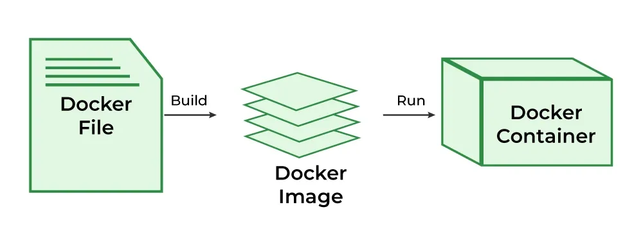

Docker Hub
A public cloud repository for Docker images.
Official site: Docker Hub

Docker Registry
A storage system for Docker images.
Types:
- Public registry
- Private registry
Examples:
- Docker Hub
- Azure Container Registry
- AWS ECR

Docker Compose
A tool used to define and manage multi-container applications.
Configuration stored in: docker-compose.yml

Volume
Volumes provide persistent storage for containers.
Used to:
- Store database data
- Preserve files after container deletion

Network
Docker networking enables communication between containers.
Types:
- Bridge
- Host
- Overlay

4. Important Docker Commands

Command | Description
docker version | Show Docker version
docker info | Show system information
docker pull | Download image
docker build | Build image
docker run | Run container
docker ps | List running containers
docker images | List images
docker stop | Stop container
docker rm | Remove container
docker rmi | Remove image
docker logs | View logs
docker exec | Execute command inside container

5. Basic Docker CLI Usage
Managing Containers
Run Container
docker run nginx
Run in Detached Mode
docker run -d nginx
List Running Containers
docker ps
List All Containers
docker ps -a

Inspecting Resources
Inspect Container
docker inspect container_id
View Logs
docker logs container_id

Removing Resources
Remove Container
docker rm container_id
Remove Image
docker rmi image_id
Remove Unused Resources
docker system prune

6. Sample Dockerfiles

Dockerfile for ASP.NET Core Web API
FROM mcr.microsoft.com/dotnet/sdk:8.0 AS build
WORKDIR /app

COPY . .

RUN dotnet restore
RUN dotnet publish -c Release -o out

FROM mcr.microsoft.com/dotnet/aspnet:8.0
WORKDIR /app

COPY --from=build /app/out .

EXPOSE 80

ENTRYPOINT ["dotnet", "MyWebApi.dll"]

Dockerfile for SQL Server
FROM mcr.microsoft.com/mssql/server:2022-latest

ENV ACCEPT_EULA=Y
ENV SA_PASSWORD=YourStrong@Pass123

EXPOSE 1433

Dockerfile for Angular Application
FROM node:20 AS build

WORKDIR /app

COPY package*.json ./

RUN npm install

COPY . .

RUN npm run build

FROM nginx:latest

COPY --from=build /app/dist/my-angular-app/browser /usr/share/nginx/html

EXPOSE 80

Docker Compose Example
version: '3.9'

services:

sqlserver:
image: mcr.microsoft.com/mssql/server:2022-latest
container_name: sqlserver
environment:
SA_PASSWORD: "YourStrong@Pass123"
ACCEPT_EULA: "Y"
ports:
- "1433:1433"
volumes:
- sql_data:/var/opt/mssql

api:
build:
context: ./api
container_name: dotnet-api
ports:
- "5000:80"
depends_on:
- sqlserver
environment:
ConnectionStrings__DefaultConnection: "Server=sqlserver;Database=MyDb;User Id=sa;Password=YourStrong@Pass123;TrustServerCertificate=True"

angular:
build:
context: ./angular-app
container_name: angular-ui
ports:
- "4200:80"
depends_on:
- api

volumes:
sql_data:

7. Running Containers
Detached Mode
Run container in background:
docker run -d nginx

Port Mapping
Map host port to container port:
docker run -p 8080:80 nginx
Format:
host_port:container_port

Environment Variables
Pass environment variables:
docker run -e ENV=production nginx

8. Building Images
Basic Dockerfile Build
docker build -t myapp .

Tagging Images
docker tag myapp username/myapp:v1

Push Image to Registry
docker push username/myapp:v1

Pull Image
docker pull nginx

9. Defining Multi-Container Applications
Services
Each containerized application component is a service.
Example:
- frontend
- backend
- database

Networks
Containers communicate using Docker networks.
Example:
networks:
app-network:

Volumes
Persistent storage for databases.
Example:
volumes:
sql_data:

10. Working with Public and Private Registries
Login to Registry
docker login

Push Securely
docker push myrepo/myimage:v1

Pull Securely
docker pull myrepo/myimage:v1

Private Registry Benefits
- Better security
- Internal image sharing
- Controlled access

11. Docker Engine Architecture
Main Components
Docker Client
CLI interface used by users.
Docker Daemon
Background service managing containers.
Docker Registry
Stores Docker images.
Docker Objects
- Images
- Containers
- Volumes
- Networks

Docker Lifecycle
Dockerfile
↓
Image
↓
Container
↓
Running Application

Resource Management
Docker manages:
- CPU
- Memory
- Storage
- Networking
Example:
docker run --memory="512m" nginx

12. Volumes and Bind Mounts
Volumes
Managed by Docker.
Example:
docker volume create myvolume
Use volume:
docker run -v myvolume:/data nginx

Bind Mounts
Maps host directory into container.
Example:
docker run -v /host/path:/container/path nginx

Persistent Storage Strategies
Use Volumes for:
- Databases
- Persistent application data
Use Bind Mounts for:
- Development
- Live code editing

Data Management Best Practices
- Backup important volumes
- Avoid storing critical data inside containers
- Use named volumes for production
- Use bind mounts during development

Summary
Docker enables:
- Lightweight application deployment
- Consistent environments
- Fast scaling
- Efficient resource utilization
Core concepts learned:
- Images
- Containers
- Dockerfiles
- Docker Compose
- Volumes
- Networks
- Registries
Docker is widely used in:
- DevOps
- Cloud-native applications
- Microservices
- CI/CD pipelines

Docker Interview Questions
- What is Docker and why is it used?
- What is containerization?
- What is the difference between virtualization and containerization?
- What are the advantages of Docker?
- What is a Docker image?
- What is a Docker container?
- What is the difference between a Docker image and a Docker container?
- What is a Dockerfile?
- What is Docker Hub?
- What is a Docker registry?
- What is the difference between Docker Hub and a private registry?
- What is Docker Compose?
- What is the purpose of the FROM instruction in a Dockerfile?
- What is the purpose of the CMD instruction in Docker?
- What is the difference between CMD and ENTRYPOINT in Docker?
- What is the use of the EXPOSE instruction in a Dockerfile?
- What is port mapping in Docker?
- What is detached mode in Docker?
- What is the purpose of Docker volumes?
- What is the difference between volumes and bind mounts?
- How do containers communicate with each other in Docker?
- What are Docker networks?
- What are the commonly used Docker network types?
- What is the difference between docker run and docker start?
- What is the purpose of the docker build command?
- What is image tagging in Docker?
- How do you push a Docker image to Docker Hub?
- What is the purpose of the docker-compose.yml file?
- What are the main components of Docker Engine architecture?
- How do you inspect logs and troubleshoot Docker containers?

